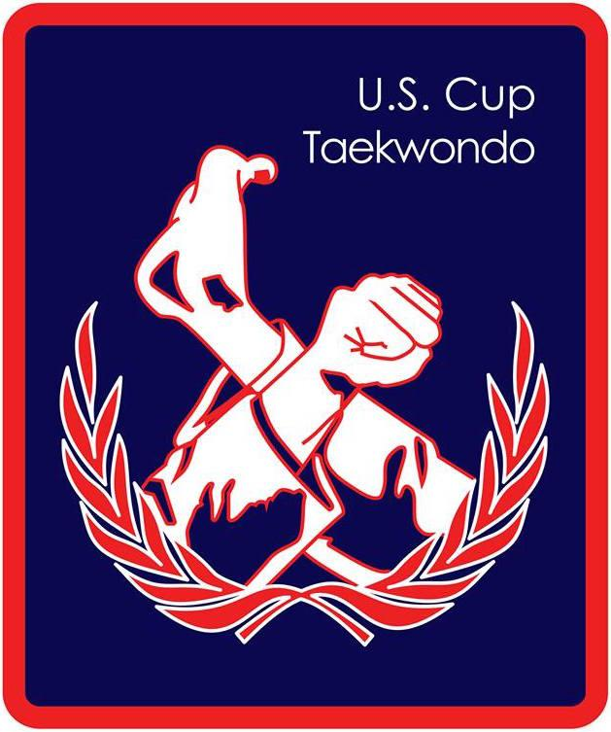 2024-25 Grandmaster Moo Yong Lee Memorial Scholarship

In memory of the late Grandmaster Moo Yong Lee, US Cup Tae Kwon Do is offering two $1,000 college scholarships for students who also practice Tae Kwon Do. This scholarship honors the life and legacy of Grandmaster Moo Yong Lee, 10th Dan, who passed away in December 2016. Grandmaster Lee dedicated his life to promote the study and practice of Tae Kwon Do in the United States. He has trained countless students, black belts, masters, and grandmasters. In recognition of his efforts and achievements, Grandmaster Lee was entered into the Tae Kwon Do Hall of Fame. “Mr. Lee” was also passionate about education, and devoted additional charitable efforts towards academic scholarships.

To be eligible for this scholarship, students must currently be participating in a belt promoting program at a dedicated Tae Kwon Do school and will be enrolled in a degree-granting nonprofit accredited college or university during the 2024-25 academic year. Two award recipients will be selected based on academic performance, achievement in Tae Kwon Do, and personal character. Personal character will be judged from extracurricular activities, community service, application responses, and letters of recommendation. In the event of equally qualified candidates, students who can demonstrate financial need and/or living or attending school in the greater New England region are preferred. The application deadline is July 31, 2024. Award winners will be notified by phone and/or email by mid-August of 2024. Funds will be sent directly to the college or university of matriculation. Scholarships are non-renewing.

US Cup Tae Kwon Do is a 501(c)(3) charitable organization whose purpose is to promote Tae Kwon Do and higher education. Our Federal tax ID number is 22-2862836. This scholarship is funded by volunteer-run Tae Kwon Do related activities and individual donations.

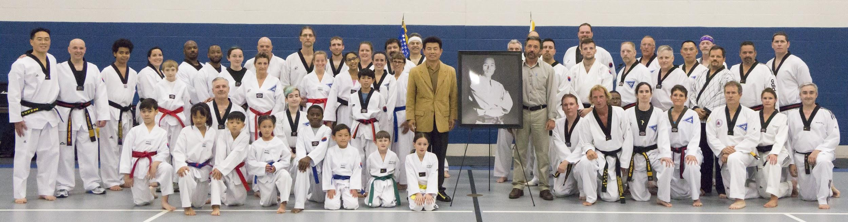
First Annual 10th Dan Grandmaster Moo Yong Lee US Cup Memorial Training Seminar - September 30, 2017

2024-25 Grandmaster Moo Yong Lee Memorial Scholarship: Eligibility and Requirements

Program: Two $1,000 college scholarships

Eligibility:
- Will be a full-time student at an accredited nonprofit college or university during the 2024-2025 academic year
- Currently participating in a belt-promoting Tae Kwon Do school
- Residents of the greater New England region are preferred

Requirements: Applicants must submit the following by July 31, 2024 (please plan ahead)
- Completed application form
- Confirming signature by your Tae Kwon Do instructor
- High school or most recent college transcript
- One or two letters of reference
- Letter of acceptance to an accredited college or university (if just graduating from high school)

Scholarship awards will be sent directly to the college or university after enrollment has been verified. Applications and supporting documents must be postmarked no later than July 31, 2024. Submissions should be mailed to:

US Cup Tae Kwon Do
c/o United Korean Martial Arts
27 Olcott St
Manchester, CT 06040

Or emailed to: uscuptkd@gmail.com

Previous Recipients:
2022-2023 | Lauren Bagshaw | Blue belt | The Hartt School, University of Hartford
 | Vivien Jiang | Blue belt | Johns Hopkins University
2020-2021 | Bennett Ducharme | 3rd Dan | Maine College of Art
 | Sarah Wilper | 2nd Dan | Colorado State University
2019-2020 | Joshua Duvall | 1st Dan | University of Connecticut
 | Rohit Kantipudi | 2nd Dan | California Institute of Technology
2018-2019 | Krister Barclay | 2nd Dan | Embry-Riddle Aeronautical University
 | Leslie Hernandez | 3rd Dan | Manchester Community College

2024-25 Grandmaster Moo Yong Lee Memorial Scholarship: Application

Name: ___________________________________ Date of Birth: _____________
Address: ________________________________________________________________
City/State/Zip: ________________________________________ _________ __________
Telephone: _______________________ Email address: _____________________________
High School: _____________________________________________________
Guidance Counselor: ________________________ Unweighted GPA _______
Taekwondo School: ________________________________ Instructor: ________________
Years of study: _________________ Your rank: ______________________
College or University you plan to attend in 2024-25: ____________________________
City/State: _____________________ ____________
Unweighted College or University GPA (if already taking classes) ______

To be considered based on financial need, please submit your parents’ tax return or FAFSA application and annual tuition. Identifying information, other than name, may be blacked out.

List any extracurricular activities that you have participated in during your most recent year of school, including sports, community service, clubs, employment, etc.

Tell us what impact Tae Kwon Do has had on you:

Tell us something else about yourself. Examples: a recent significant experience or event, something you are passionate about, why you should receive this scholarship:

The above statements are true to the best of my knowledge. I understand all materials are confidential, and all submissions remain the property of US Cup Tae Kwon Do and cannot be returned. I understand that if I do not complete the application process or if my application is postmarked after July 31, 2024, I am not eligible for consideration. I agree to allow my name to be used for publicity purposes at fund raising events, online, and other local news outlets.

Signature: ____________________________ Date: _______________

Statement from your Tae Kwon Do instructor:

I confirm that the above-named student is enrolled in my school. He/she has been studying Tae Kwon Do for ______ years and has achieved the rank of ______________. My governing organization is _________________________.

Name: _______________________ Signature: ____________________________ Date: __________

